HANDY COMMANDS FOR LINUX SYSTEM
Check if aport is in use. | Lsof -i :<portnumber>
Kill a process with its process id | Sudo kill <processno>
Systemctl

USERS AND GROUPS
List all users | Cat /etc/passwd
If user aayushi tries to access root she will not be allowed. | 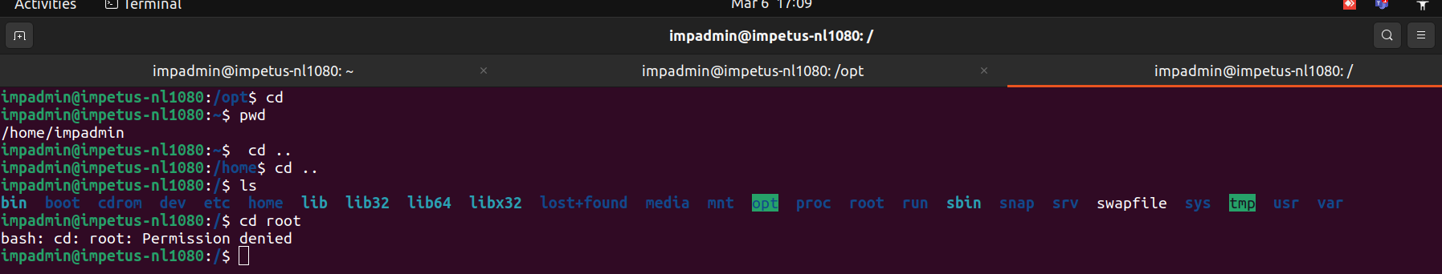
To login as a root user:sudo su | 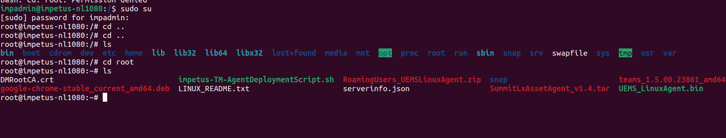
Dlete a user:to dlete a user login as aroot user and do | Deluser <name>
Chnaging password of a user | 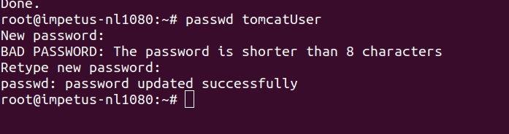
Adding a user to a group and checking groups in which a user is | 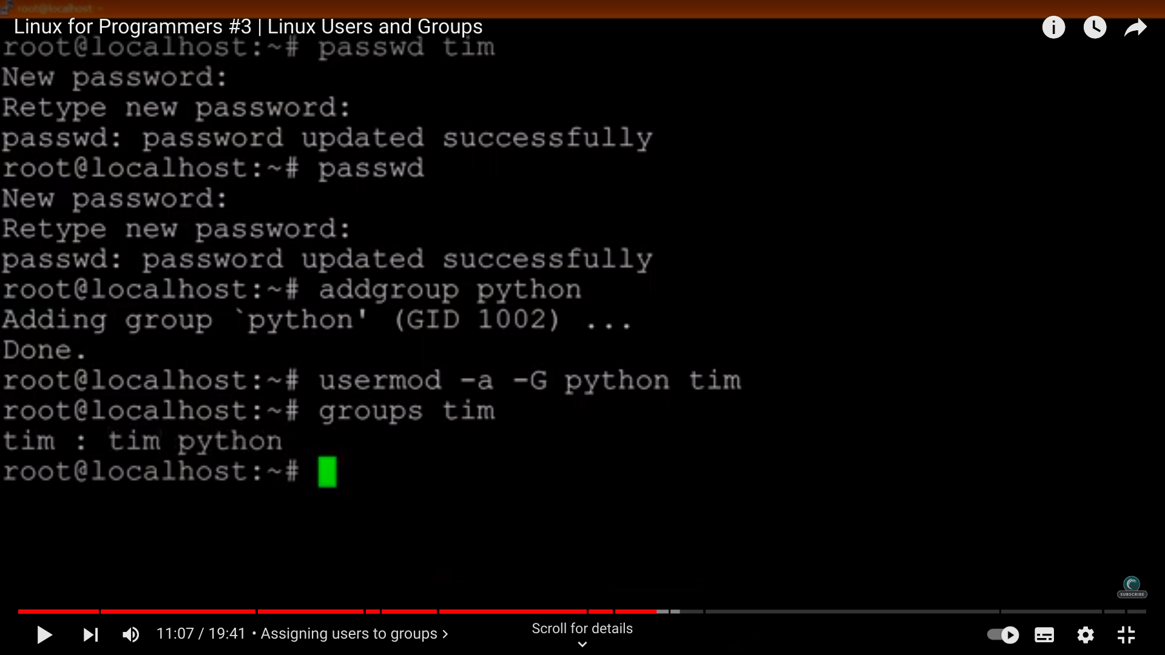
Visudo:  giving acesses to a user | 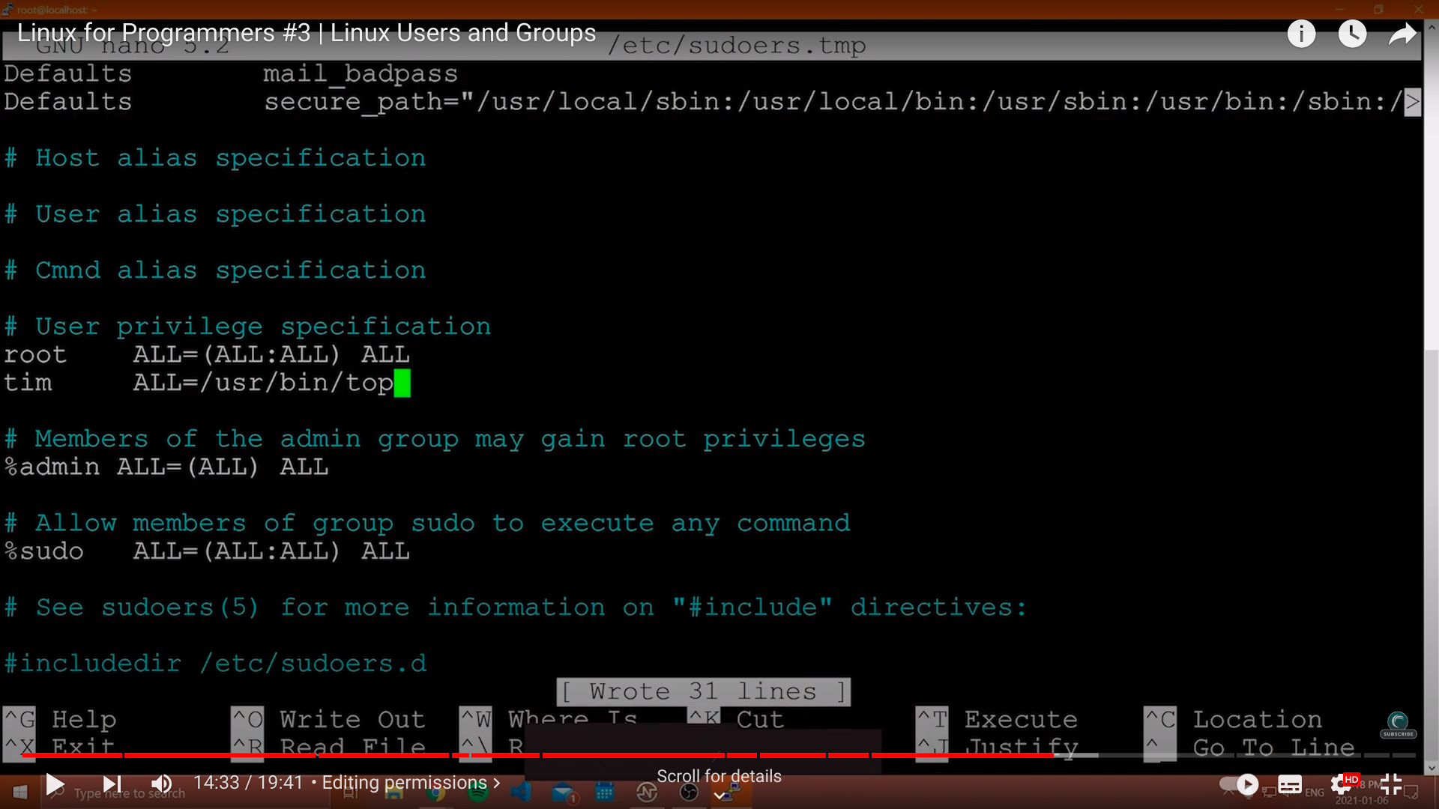
Permissionns
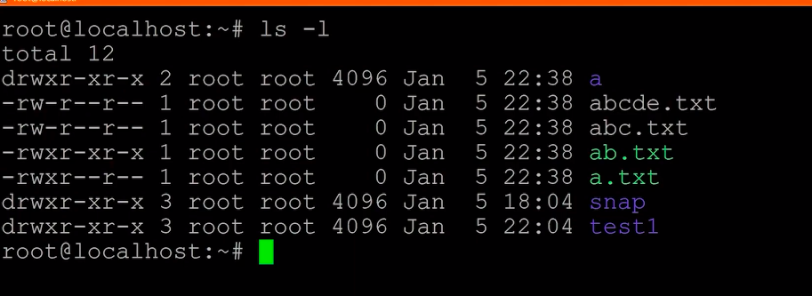
To check which file has what acess in a directory
Drwxrwxrwx::typically means permisiion groups a | here[user][group][allusers]
Changing permisiions  chmod [who][+,-,=][permissions] filnemae | 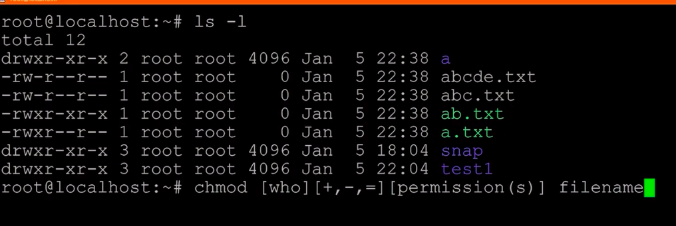
Chmod a(allusers)/o(other users) +/-/= [permission | 